Jenkins Assignment -2
- Job -1
- Repo details –
https://github.com/amitchandole05/Jenkins-assignment.git
Branch - */master
- Shell Script –
cd /var/www/html
rm -rf *
service httpd start
cp -r /root/.jenkins/workspace/Jenkins-Assignemnt-1/index.html .
chmod 644 index.html

cd /root/.jenkins/workspace
rm -rf *
- Assessing the Website
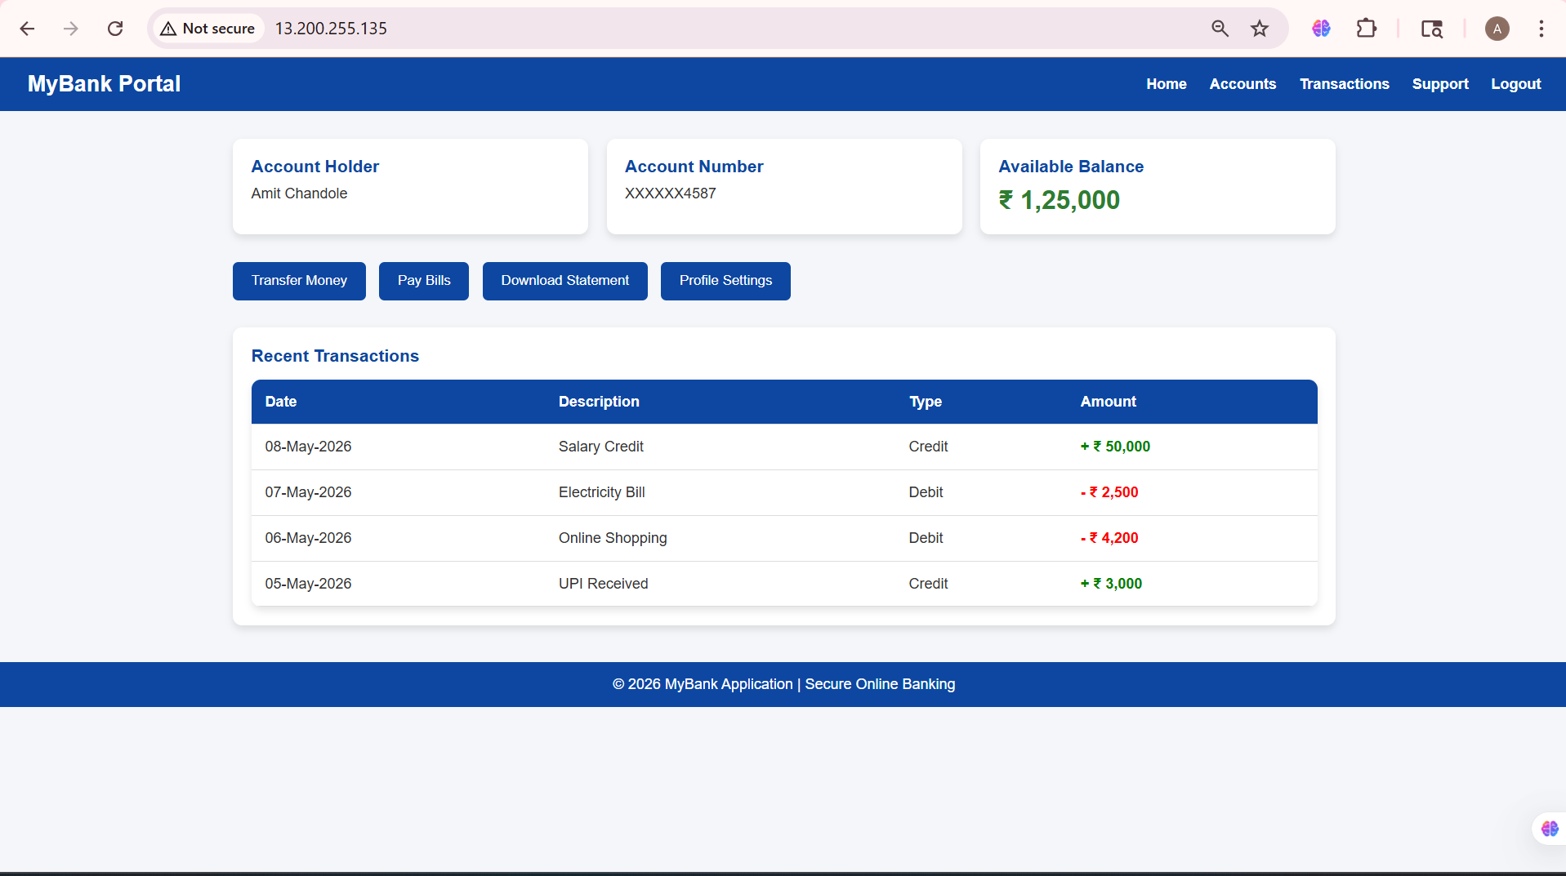

- Job-2
- Repo Details –
https://github.com/amitchandole05/amruta-shop.git
Branch – */master
- Shell Script –
cd /var/www/html
rm -rf *
service httpd start
cp -r /root/.jenkins/workspace/Jenkins-Assignemnt-2-job-2/index.html .
chmod 644 index.html

cd /root/.jenkins/workspace
rm -rf *
- Assessing the Website

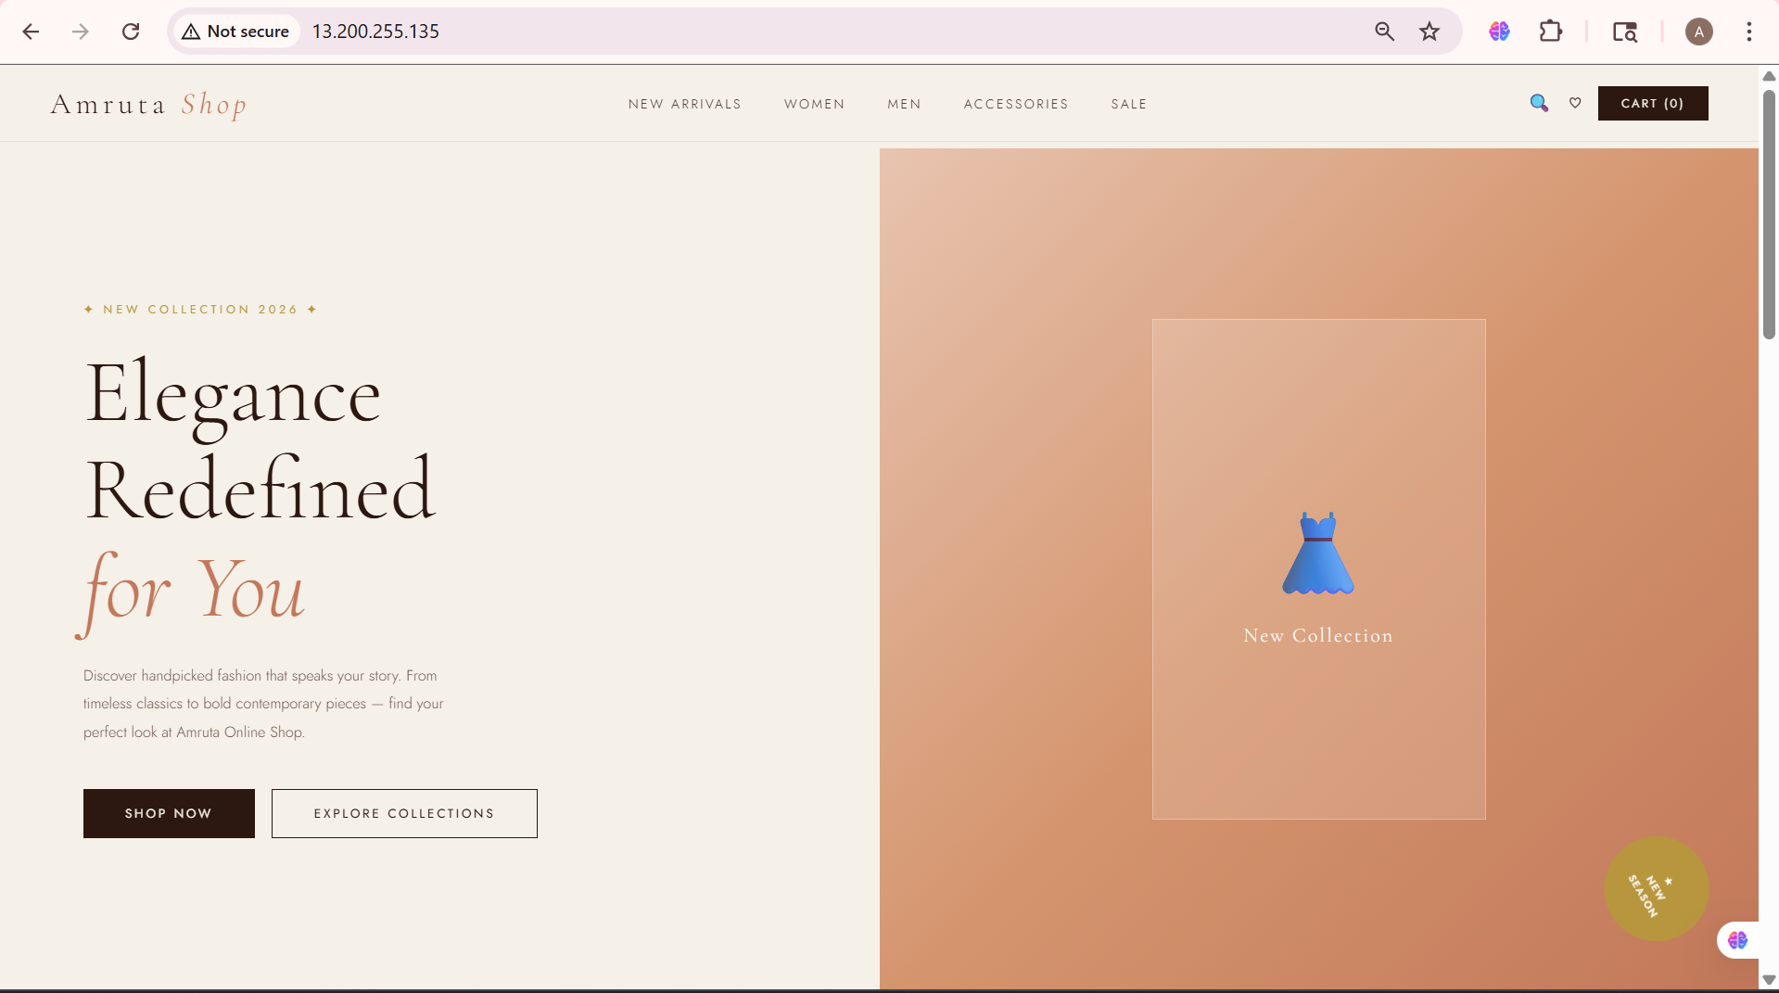

- Job 3
- Repo details
https://github.com/amitchandole05/amruta-mart.git
Branch – */2026q2
- Shell Script
cd /var/www/html
rm -rf *
service httpd start
cp -r /root/.jenkins/workspace/Jenkins-Assignment-2-Job-3/index.html .
chmod 644 index.html

cd /root/.jenkins/workspace
rm -rf *
- Assessing the Website
